⮊ ATTENDANCE Check-In is working in Infinite Campus. Instead of clicking the "Attendance" tab on the left stay on the "Today" tab. Under your picture you will see Check-Ins and then your schedule listed.

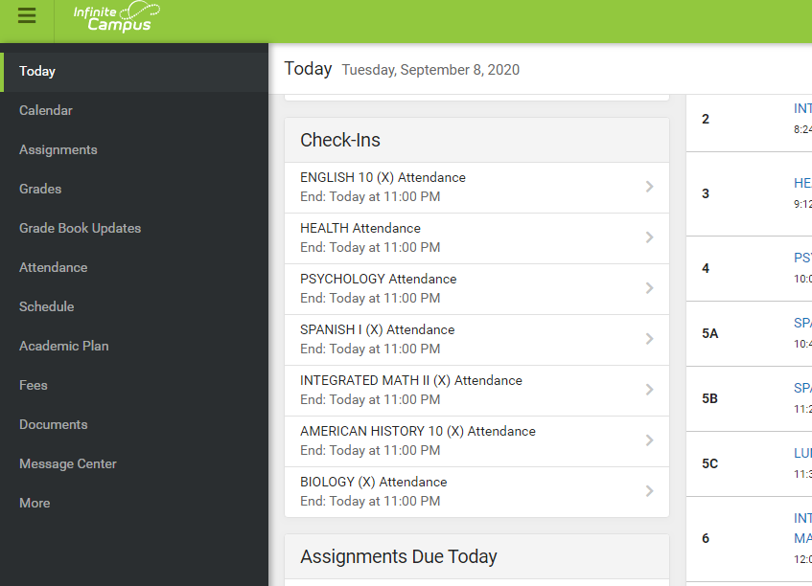

⮊ Click on each class and then click the “Yes, I’m Here” button to Check-In for the day. That class should then disappear from your Check-Ins list for today.

